[Getting Started for Web - Docs - Appwrite](https://appwrite.io/docs/getting-started-for-web)

[Appwrite crash course | Open Source Backend as a Service | Reactjs](https://youtu.be/jkngyZjRETs)

[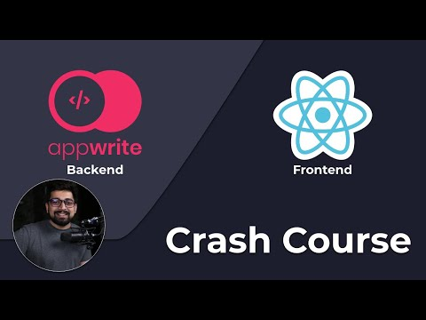](https://youtu.be/jkngyZjRETs)

<https://github.com/appwrite/demo-todo-with-react>